**Keyestudio Nano Board**

1. **Description**

The processor core of Keyestudio Nano CH340 is ATMEGA328P-AU. It is as same as the official Arduino Nano in addition to driver file and USB to serial chip (CH340G).

It also has 14 digital input / output interfaces (6 of which can be used as PWM output), 8 analog input interfaces, 1 16MHz crystal oscillator, 1 mini USB port, 1 ICSP interface, and a reset button.

The ICSP interface is used to program the Atmega328P-Au. We can supply power with a USB cable, the port VIN GND (DC 7-12V) and GND

1. **Specification**

Microcontroller：ATMEGA328P-AU

Operating Voltage: 5V

Input Voltage (recommended)：DC 7-12V

Digital I/O Pins：14 (D0-D13)

PWM Digital I/O Pins：6 (D3 D5 D6 D9 D10 D11)

Analog Input Pins: 8 (A0-A7)

DC Current per I/O Pin: 40 mA

Flash Memory：32 KB of which 2 KB used by bootloader

SRAM: 2 KB

EEPROM: 1 KB

Clock Speed: 16 MHz

LED_BUILTIN: D13

1. **Pins**

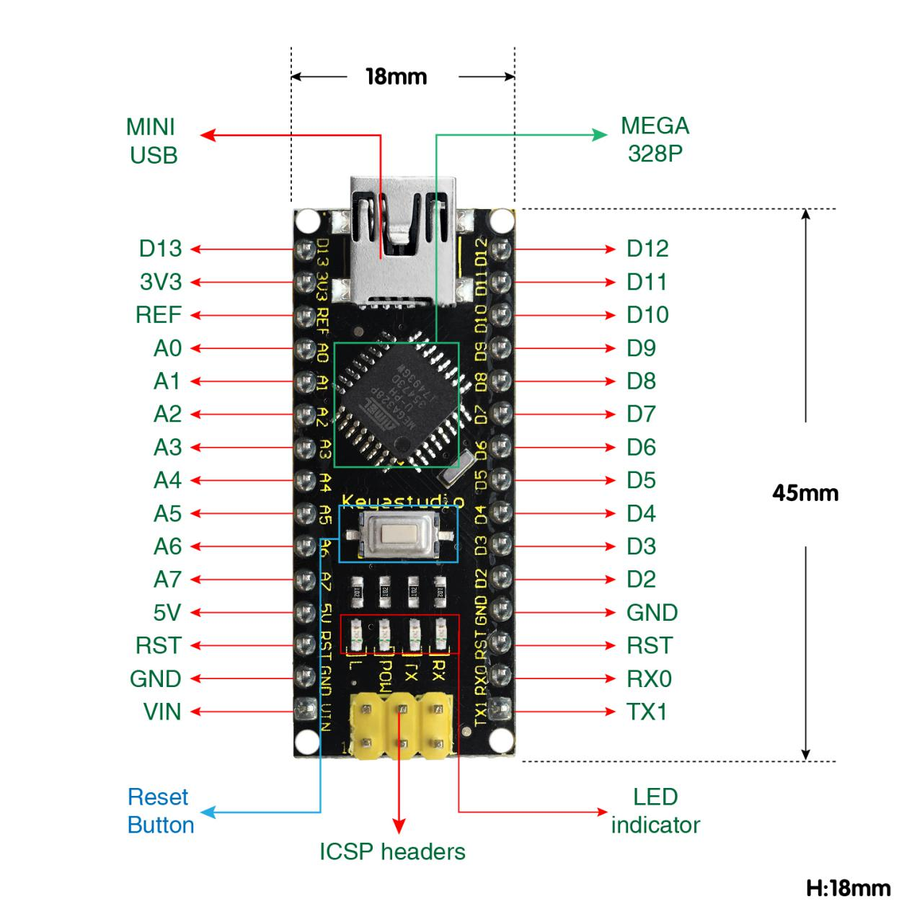

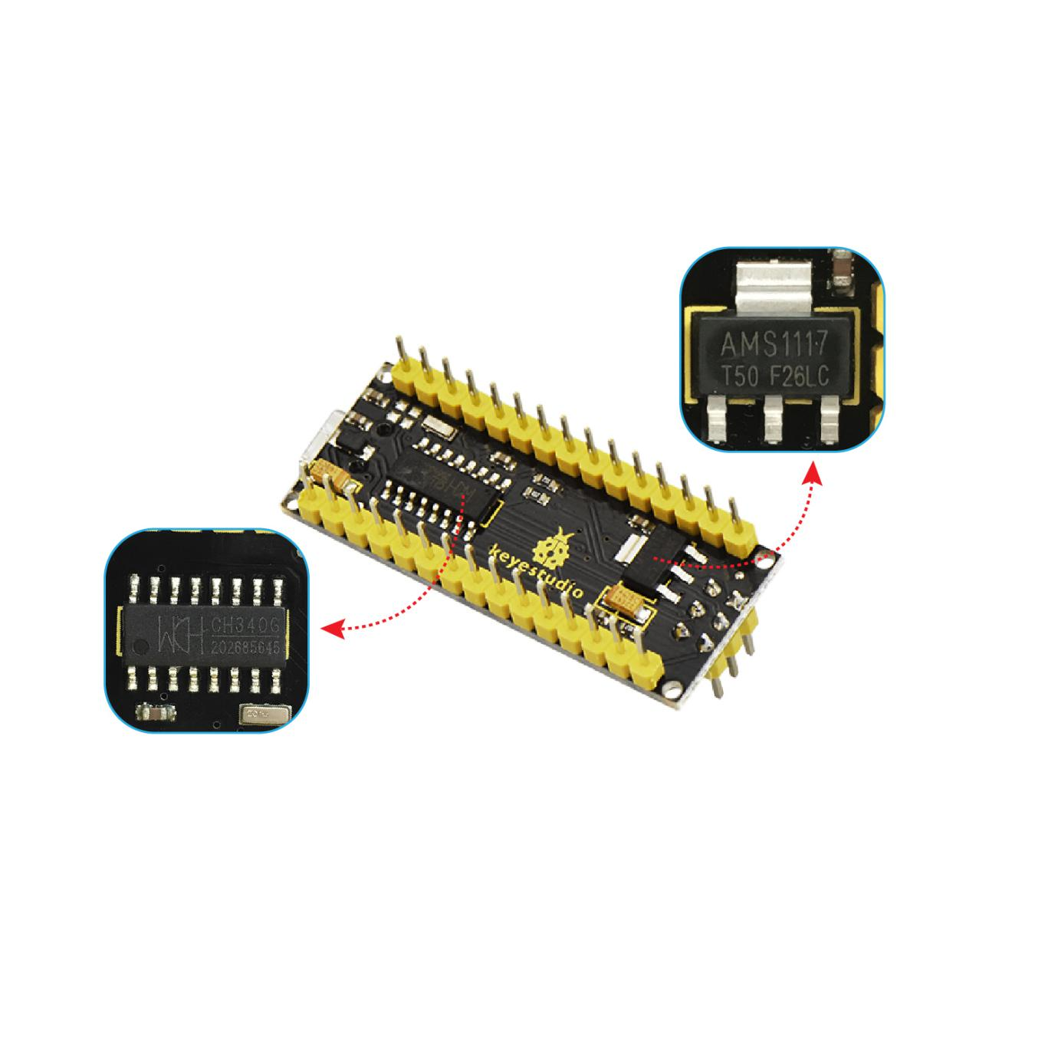

|  |  |  |
| --- | --- | --- |
| **1** | **ICSP Header** | **ICSP (In-Circuit Serial Programming) Header**  ICSP is the AVR, an micro-program header consisting of MOSI, MISO, SCK, RESET, VCC, and GND. It is often called the SPI (serial peripheral interface) and can be considered an "extension" of output. In fact, slave the output devices under the SPI bus host.  When connecting to PC, program the firmware to ATMEGA328P-AU. |
| **2** | **LED indicator**  **（RX）** | Onboard you can find the label: RX(receive )  When control board communicates via serial port, receive the message, RX led flashes. |
| **3** | **LED indicator**  **（TX）** | Onboard you can find the label: TX (transmit)  When control board communicates via serial port, send the message, TX led flashes. |
| **4** | **LED indicator**  **（POW）** | Power up the control board, LED on, otherwise LED off. |
| **5** | **LED indicator**  **（L）** | There is a built-in LED driven by digital pin 13. When the pin is HIGH value, the LED is on, when the pin is LOW, it's off. |
| **6** | **RX0（D0）**  **TX1（D1）**  **D2-D13** | It has 14 digital input/output pins D0-D13 (of which 6 can be used as PWM outputs). These pins can be configured as digital input pin to read the logic value (0 or 1). Or used as digital output pin to drive different modules like LED, relay, etc. |
| **7** | **RST** | Reset pin: connect external button. The function is the same as RESET button. |
| **8** | **MEGA 328P** | Each board has its own microcontroller. You can regard it as the brain of your board.  Microcontrollers are usually from ATMEL. Before you load a new program on the Arduino IDE, you must know what IC is on your board. This information can be checked at the top surface of IC.  The board’s microcontroller is ATMEGA328P-AU.  More info. see the [datasheet](http://101.96.10.64/ww1.microchip.com/downloads/en/DeviceDoc/Atmel-42735-8-bit-AVR-Microcontroller-ATmega328-328P_Summary.pdf) |
| **9** | **MINI USB** | The board can be powered via Mini-B USB connection. Also upload the program to the board via USB port. |
| **10** | **3V3 pin** | Provides 3.3V voltage output |
| **11** | **REF** | Reference external voltage (0-5 volts) for the analog input pins. Used with [analogReference()](https://www.arduino.cc/reference/en/language/functions/analog-io/analogreference/). |
| **12** | **A0-A7** | The Nano has 8 Analog Pins, labeled A0 through A7. |
| **13** | **5V** | Provides 5V voltage output |
| **14** | **GND** | Ground pin |
| **15** | **VIN** | Input an external voltage DC7-12V to power the board. |
| **16** | **Reset**  **Button** | Used to reset the control board |
| **17** | **CH340G** | USB-to-serial port chip, converting the USB signal into Serial port signal. |
| **18** | **AMS1117** | Convert the external voltage input DC7-12V into DC5V, then transfer it to the processor and other elements. |

# 3. Specialized Functions of Some Pins:

* **Serial communication:** RX0 and TX1.
* **PWM (Pulse-Width Modulation):** D3, D5, D6, D9, D10, D11
* **External Interrupts:** D2 (interrupt 0) and D3 (interrupt 1).
* **SPI communication:** D10 (SS), D11 (MOSI), D12 (MISO), D13 (SCK).
* **IIC communication:** A4 (SDA); A5(SCL)